# Egress Profisee REST API to ADLS Gen2 CSV Format

This article describes a solution template that you can use to copy member data from Profisee REST API to Azure Data Lake Storage Gen2 CSV storage.

## About this solution template

This template retrieves member data from Profisee REST API. It then copies the member data, in CSV format, to a file in the Sink container. The template will create a folder for the entity and copy the file to that folder. The file name is composed of the entity name and date/time in UTC with the .csv extension.

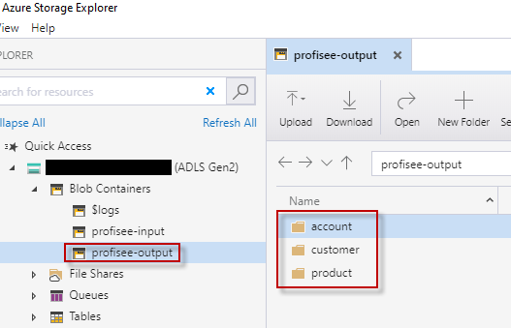

**How to use this solution template**

1. Go to the **Egress Profisee REST API to CSV** template.

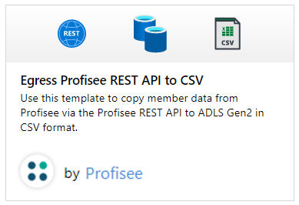

1. Create a **New** or use an existing connection to the source Profisee REST API.

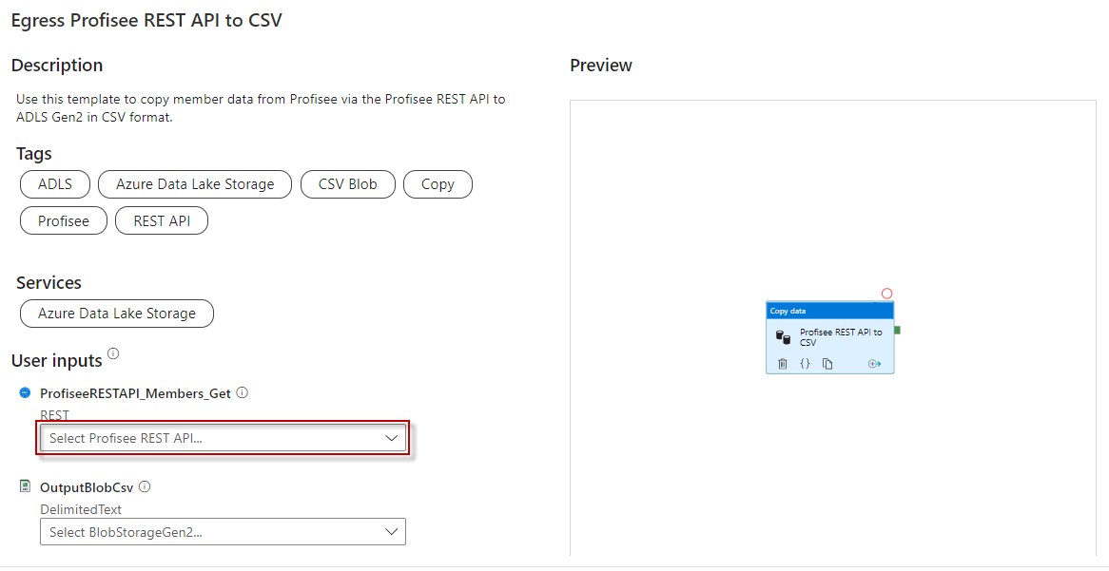

* 1. Follow these steps if you need to create a new REST linked service.
  2. Select “+ New" from the **REST** dropdown list.

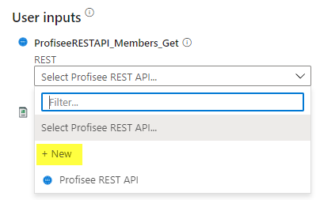

* 1. Enter the following information for the REST linked service.
     1. Name: Enter a unique name within your ADF.
     2. Description: Enter an optional description.
     3. Integration runtime: You can select the auto resolve option or create a custom integration runtime. Some linked services that ADF integrates with requires the ADF integration runtime be in the same region as the service. In this case you will need to create a custom integration runtime in the same region as that linked service.
     4. Base URL: enter the base URL to your deployed Profisee REST API.
     5. Authentication type: select **Anonymous**

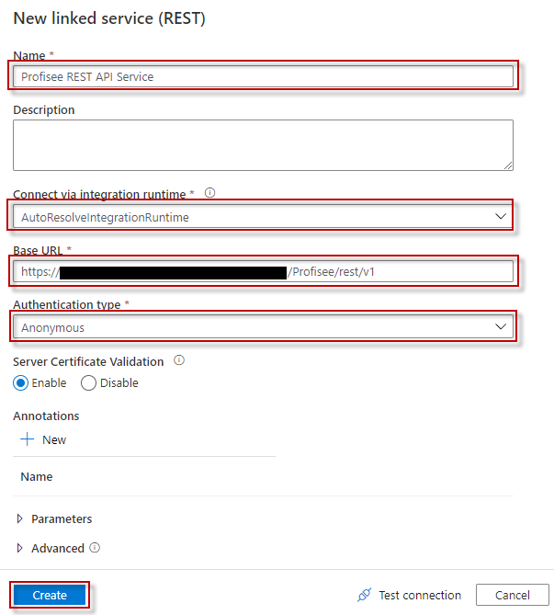

1. Create a **New** or use an existing connection to the ADLS Gen2 sink data store that you are copying data to.

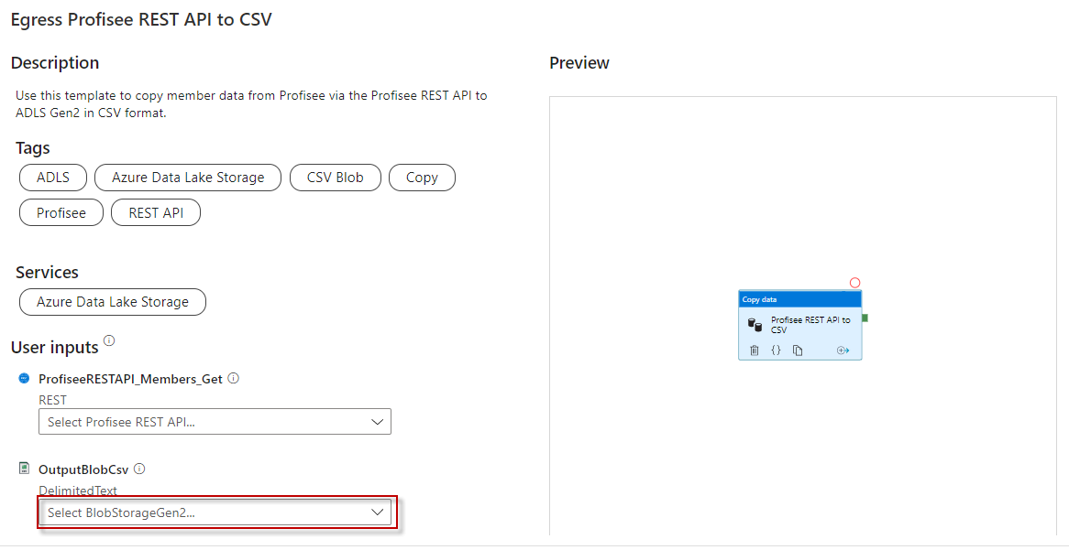

1. Select **Use this template**.

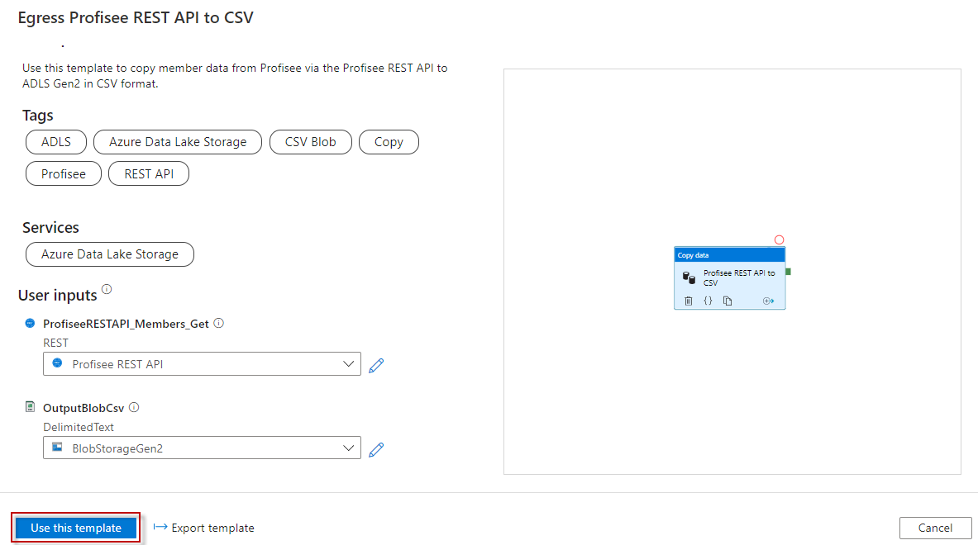

1. You will see a pipeline created as shown in the following example:

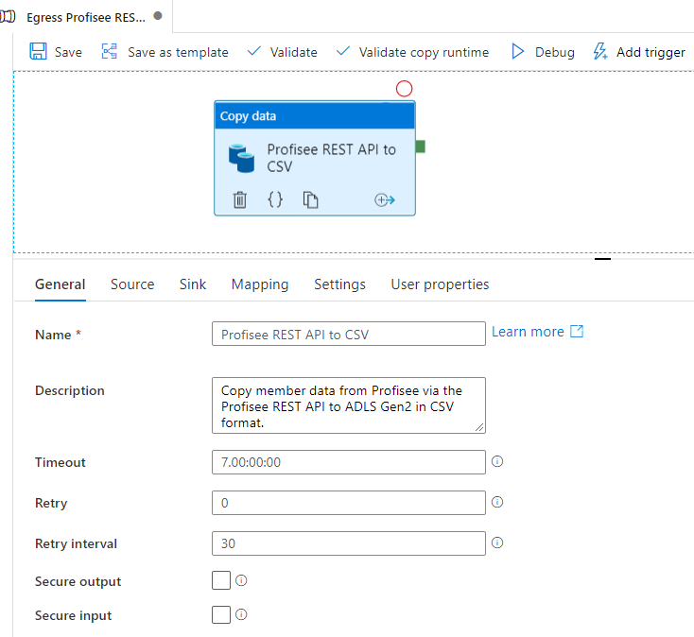

You should also see the following template validation output.

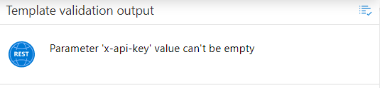

There are three items needed for the pipeline, one of them are mentioned above.

* 1. **EntityName:** The entity you are copying member data for. This is entered in the pipeline Variables tab.

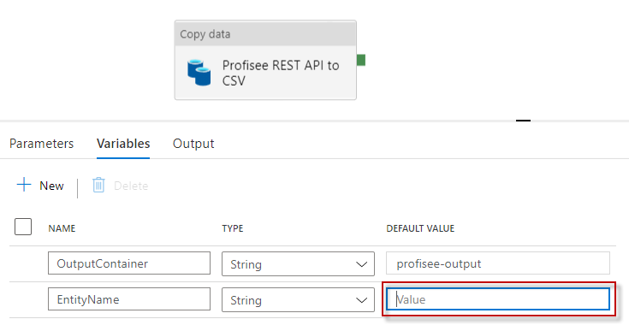

* 1. **Container:** The output container where you are copying the file to. This is entered in the pipeline Variables tab. It defaults to “profisee-output”. You can update to another name based on your environment.

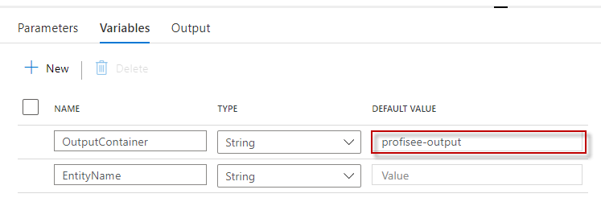

* 1. **x-api-key:** The Profisee API key, which is the Client Id for the user account you are using to connect to the Profisee API. This is entered in the Source tab.

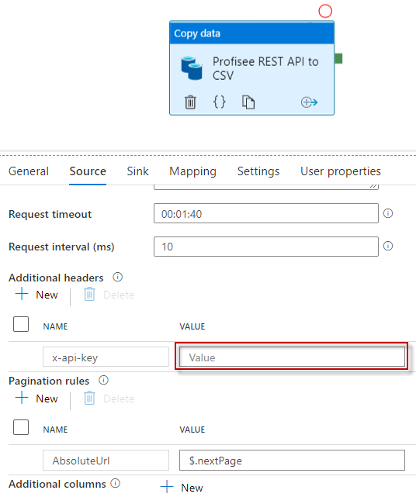

1. Select **Mapping** tab to map the member data result properties to the corresponding CSV column.

First click the **Import Schemas** button. You will be prompted to confirm the value of the pipeline parameter for the EntityName. Click **OK**.

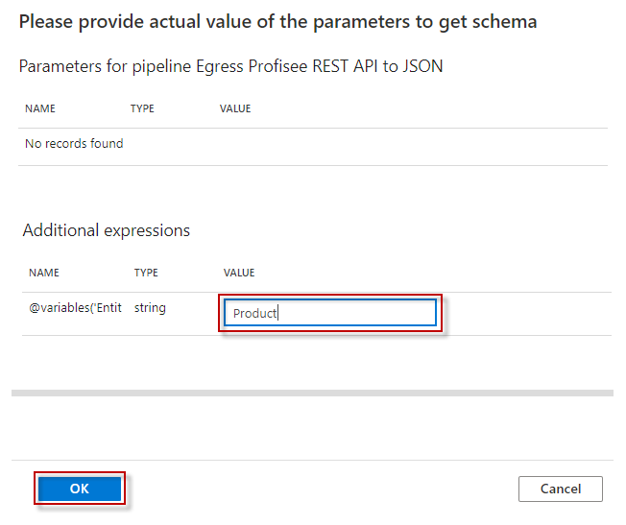

After a couple of seconds, you will see a list of mapping fields listed, as shown in the following example.

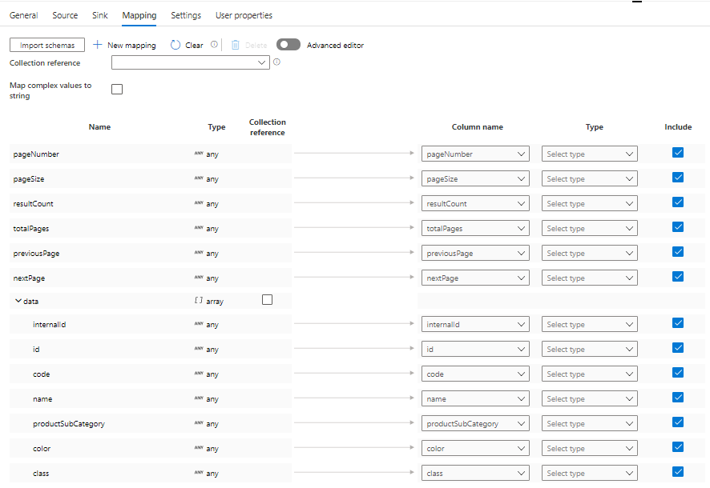

Next, select **data** from the **Collection reference** drop down list. The **data** property is the array of member data.

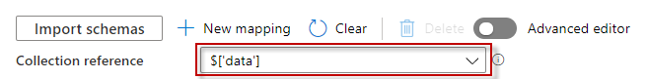

Unselect the Include checkboxes for the pageNbr, pageSize, resultCount, totalPages, totalRecords, and nextPage properties as we do not want to copy them to the file.

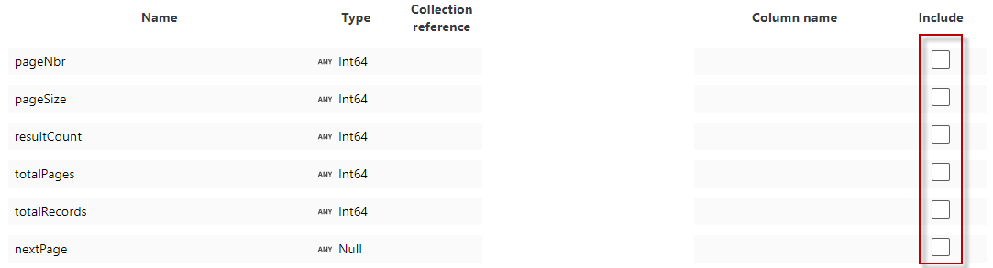

After selecting the data collection reference, you need to select the Type for each field you want to copy.

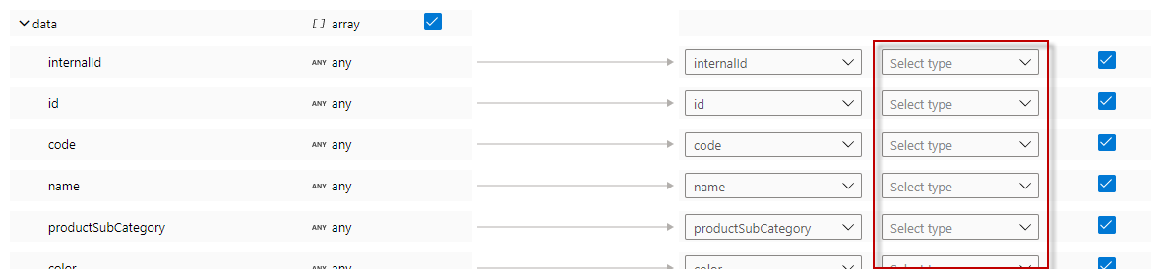

1. Once you are finished with all your changes, click Publish All.



1. To run the pipeline now, select **Add Trigger** and select **Trigger now**. Press **OK** at the Pipeline run prompt.
2. Select **Monitor** tab in the left navigation panel and wait for about 20 seconds. Click **Refresh** to get the updated run status.
3. When the pipeline run completes successfully, you would see results like the following example:

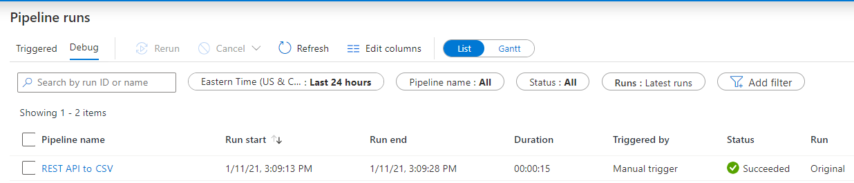

1. You should also see the output file in the Container and Directory you entered.

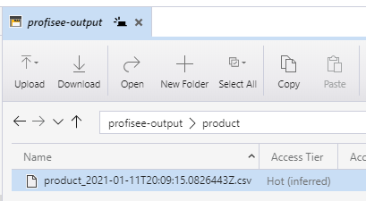

## Source parameters

You can customize the member data get API query with the following parameters.

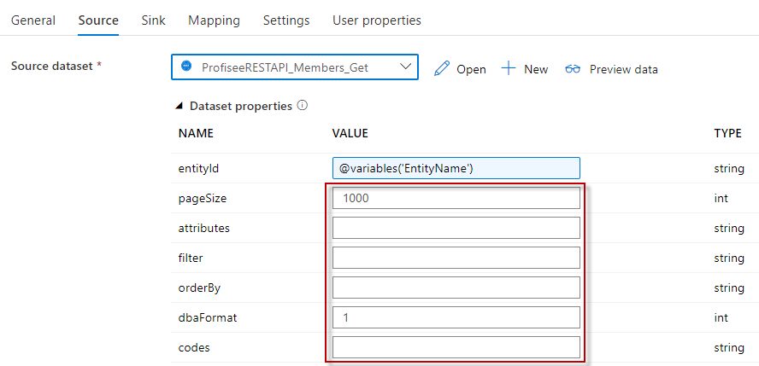

* pageSize - The page size to get.  Defaults to 1000 if not supplied.
* filter - A filter to restrict the members returned.
  + <attribute name> <operator> <value>. E.g. Color = ‘BLU’. **NOTE**: This syntax will be changing slightly in the GA release.
  + You can group attributes together using parenthesis and ANDs and ORs.
  + You can also filter on AuditInfo columns.  Use the following property names:
    - created On (datetime) - datetime the record was created, in UTC
    - created By (string) - user that created the record
    - changed On (datetime)) - datetime the record was last changed, in UTC
    - changed By (string) - user that last changed the record
* attributes - A comma separated list of entity attribute names to return.  Can include MLAs with dot notation. If blank, all attributes are returned. Note: the attribute list determines the result properties you will see in the **Mapping** tab.
  + Multi-level attributes are supported, using the dot notation format to designate the MLA path
  + Example: Color,Class,ProductSubCategory,SellStartDate,SellEndDate,Weight,ProductSubCategory.ProductCategory.ProductGroup
* orderBy - A comma separated list of entity attribute names and direction to order the response
  + <attribute name> or <attribute name> asc - sorts attribute in ascending order
  + <attribute name> desc - sorts attribute in descending order
  + Example:
    - ProductSubCategory, SellStartDate desc
* dbaFormat - The domain-based attribute (DBA) format to return. Provides an option to indicate how to return the DBA's Code and Name.  Note: a DBA is an attribute that points to, or references, another entity, called a domain entity.
  + Code only (default) - Only return the code value.
    - Example:
      * "Source System": "SF",
  + Code and Name simple properties.  The name property is returned as DBA.Name.
    - Example:
      * "Source System": "SF",
      * "Source System.Name": "Salesforce",
* codes – A comma separated list of member codes to return.

## Sink parameters

You can customize the directory and file name by changing the template values for the following parameters.

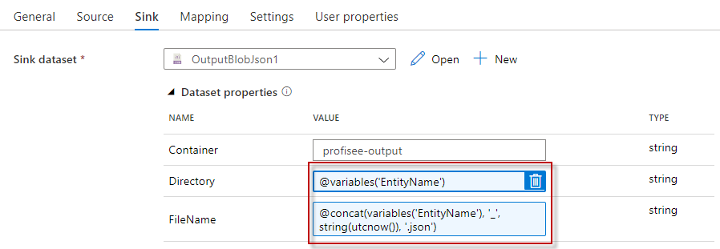

## Next steps

* [Introduction to Azure Data Factory](https://github.com/MicrosoftDocs/azure-docs/blob/master/articles/data-factory/introduction.md)